1. Data Range Selection
You can now specify a start and end date for your backtest.
This lets you run your strategy over only part of the available dataset - for example:
To use one date range for training, another for validation, and another for testing.
To study how your strategy behaves under different market conditions.
Example usage:
python main.py --strategy my_strategy --data-dir ./DATA/PART1 --start 2070-01-01 --end 2072-01-01
The framework will automatically trim the CSV data to the specified period before passing to your strategy. (It does not alter the CSV files).
Upon running a backtest, you will see a summary of the date range being used.
2. Updated JSON Output Summary
After each backtest, you’ll now see an output block like this:
{
"final_value": 999480.0232084402,
"bankrupt": false,
"bankrupt_date": null,
"open_pnl_pd_ratio": -0.7947544543252159,
"true_pd_ratio": -0.8055126668246864,
"activity_pct": 97.69769769769769,
"end_policy": "liquidate",
"s_mult": 1.0
}
final_value: Your final portfolio value, including all slippage, trading costs, and final liquidation.
bankrupt: Indicates whether the portfolio went below zero at any point.
bankrupt_date: The date bankruptcy occurred (if applicable).
open_pnl_pd_ratio: PD ratio based on open-to-open (idealised) cumulative PnL - ignores trading frictions.
true_pd_ratio: PD ratio based on the true broker equity curve - includes all slippage, costs, and final liquidation. This is your true performance metric.
activity_pct: The percentage of trading days on which the strategy placed at least one order.
end_policy: The rule applied at the end of the backtest (should always be liquidate).
s_mult: Slippage multiplier applied to simulate execution friction (e.g. 1.0 = 20% default slippage). Should be 1.0 unless you specifically want to change it for a test.
Important
The previous PD Ratio calculation (kept in the framework as 'open_pnl_pd_ratio'), does not include trading frictions. However we want to include all extra costs when calculating the PD ratio and comparing with other strategies, so the new metric, true_pd_ratio, in the new version of the Backtest Framework does.
The True PD Ratio is now the main performance figure that your strategy should aim to improve.
The Open PnL PD Ratio remains useful for analysing your strategy’s theoretical performance under perfect (frictionless) trading conditions - but it does not include slippage or execution costs.
The True PD Ratio does. True PD Ratio will be the figure used for evaluation purposes.
3. Improved Graphs and PD Ratio Visualization
All graphs have been refreshed to show clearer information, consistent labelling, and new legends.
Some now include the True PD Ratio directly on the charts and some include the Open-open PnL PD Ratio (the old PD ratio) so you can see the difference between ideal and real performance.
4. The True Equity Curve
A new plot called True Portfolio Equity (or True Equity Curve) has been added.
This is the actual value of your trading account over time, including:
* Your cash balance
* The current value of all open positions
* All slippage and trading costs
* Final liquidation at the end of the test
It shows what your 'broker' account would really be worth each day in practice, not just the paper (open PnL) value.
5. The Realized CumPnL Curve
The Realized Cumulative PnL curve shows only profits and losses that have actually been realised (from closed trades).
It excludes unrealised changes in open positions.
Think of it as the “money in the bank” curve - your running total of locked-in gains and losses.
It will normally lag behind the open-to-open curve and catch up only when all positions are closed.
6. New Input Data Plotting Feature
You can now easily plot your raw input data (and optionally normalised data) before running any strategies. This is useful for visually examining your input data for any obvious trends.
Example commands:
# Plot all 10 series (raw only)
python plot_input_data.py --data-path ./DATA/PART1
# Plot all 10 series, with additional normalised chart
python plot_input_data.py --data-path ./DATA/PART1 --normalise
# Plot only series 2 and 9 (raw)
python plot_input_data.py --data-path ./DATA/PART1 --series 2 9
# Plot series 2 & 9, both raw and normalised
python plot_input_data.py --data-path ./DATA/PART1 --series 2 9 --normalise
Output files appear in:
output/
├─ input_data_plot.png
└─ input_data_plot_normalised.png
7. Google Colab (for Data Analysis)
When using the second set of data, it is necessary to prove that the decision to choose the three strategies is reasonable. One useful thing in this regard is to visualize and analyze the input data. It is recommended to use Jupyter Notebook or Google Colab，here is a tutorial：https://www.pyquantnews.com/the-pyquant-newsletter/3-examples-pandas-financial-market-data-analysis.
Below shows how to plot input data, and should give you a good starting point to do any other analysis of the data that you may need to do.
It uses the pandas python data science library.
You need to make sure you can access Google Colab:
https://colab.research.google.comLinks to an external site.
Click “New Notebook” (bottom left).
Now click on Add code, and put this in the cell:
from google.colab import files
uploaded = files.upload()
and click the ‘play’ button to run it.
This opens a file picker — select your 10 ‘part1’ CSVs.
They’ll be stored in Colab’s temporary workspace (RAM-based /content/ directory).
Now add a new code cell (add code). In this one, paste this, and click ‘play’ to run:
This code will just plot the input data – you’ll probably want to adjust it to get interesting stuff out of it.
import pandas as pd
import matplotlib.pyplot as plt
import glob

# Load all CSV files in the current directory
files = glob.glob("*.csv")

# Read and combine Close prices
dfs = {}
for f in files:
name = f.split('.')[0]
df = pd.read_csv(f)
df['Index'] = pd.to_datetime(df['Index'])
df = df[['Index', 'Close']].rename(columns={'Index': 'Date', 'Close': name})
dfs[name] = df

# Merge all on 'Date'
merged = dfs[list(dfs.keys())[0]]
for name, df in list(dfs.items())[1:]:
merged = merged.merge(df, on='Date', how='inner')

merged.set_index('Date', inplace=True)

# Plot all Close price series
plt.figure(figsize=(12, 6))
for col in merged.columns:
plt.plot(merged.index, merged[col], label=col)

plt.title("Close Price Series")
plt.xlabel("Date")
plt.ylabel("Price")
plt.legend()
plt.grid(True)
plt.show()
# scale to 0-1 – this will probably be quite messy, there are probably better ways to visualise/compare than this, but it’s a starting point.
merged_minmax = (merged - merged.min()) / (merged.max() - merged.min())
merged_minmax.plot(figsize=(12,6), title="Min–Max Normalised Prices (0–1 Scale)")
plt.xlabel("Date")
plt.ylabel("Scaled Price (0–1)")
plt.show()
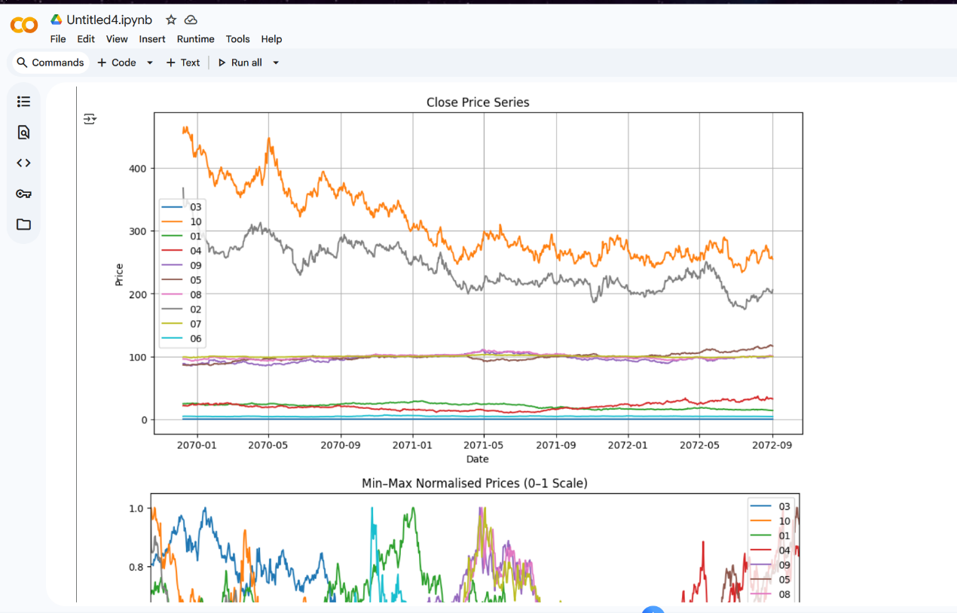
8. Example strategies fixed
Some of the example strategies were not actually doing any trading because they were using Backtrader commands directly to trade, so bypassing the BT396 rules. The example strategies had been rewritten so that they now conform correctly to the BT396 commands.
9. Using Backtrader API calls directly
Previously this just didn't work, but it failed silently. It had been modified so that any attempt to use the Backtrader API calls directly just gets passed through the BT396 framework.

